PathSimR – A&E Example

# Problem

## Project title & summary

Proportion of patient time spent waiting in an emergency department under crisis conditions. This is an example use case, adapted and simplified from a published model.[1]

## Key questions & insights

The main question is how well does a disaster contingency plan – in terms of resource re-allocation between parts of an emergency department – provide resilience to a major event in terms of proportional waiting times for the most seriously ill/injured patients. The major event is modelled in terms of a steep but time-limited increase in arrival rates and the emergency resilience plan is modelled in terms of changes to service rates and capacities at given service points, to reflect the reassignment of doctors and nurses between service points (and potentially the opening of extra treatment rooms and the spreading of doctor/nurse resource between them).

A reference case pathway is specified and what-if analysis then is performed by adding/removing service points of a given type and/or changing capacity and service time parameters within service points, and comparing the resulting differences in mean patient waiting time to total time in system ratios. The comparative effect of the changes on more severe patients is examined by looking at these measures for given service points, as well as for the whole pathway.

## Key PathSimR Features

* High capacity internal queue system
* Rejection at full external queues (patients will be lost if there is no space upon arrival from outside the system)
* Small cycle within the network
* Calendar driven capacity changes (See ‘Shock Room’)
* Multiple external arrival points, each with a unique arrival calendar with a mix of rates

## Summary of services along patient pathway

Patients arrive at the emergency department by different routes and with different severities of illness/injury, and are categorised as “red”, “yellow”, “green”, or “white”. These follow largely discrete pathways through the department and are modelled as having separate arrival rates (in the case of “yellow”, two separate arrival rates depending on the initial service point they are triaged to).

Service points specific to particular arrival rates are named accordingly below. Note also that one of the elements to be modified in the “what-if” analysis could be to vary the number of service points associate with a particular class of arrivals (e.g. adding a second “yellow” emergency room, and splitting the associated “yellow” arrival rates between them), and/or to modify the service rates associated with those units (to represent the effect of sharing fixed human resources between them).

|  |  |  |
| --- | --- | --- |
| Service Point | Service Point Type | Description |
| Shock room (“red”) | A&E Unit | * Capacity changes on a 24 hour cycle   + 8am to 8pm – 6   + 8pm to 8am – 3 * Service time is modelled as a A&E with mean 0.8 |
| Intensive treatment (“red”) | A&E Unit | * Capacity – 4 * Service time is modelled as an A&E with mean = 0.8 |
| Observation room (“yellow”) | A&E Unit | * Capacity – 8 * Service time is modelled as an General Medicine – All with mean = 1 |
| Emergency treatment (“yellow”) | A&E Unit | * Capacity – 5 * Service time is modelled as an A&E with mean = 1 |
| Emergency treatment (“green”) | A&E Unit | * Capacity – 10 * Service time is modelled as an A&E with mean = 1 |
| Examination room | A&E Unit | * Capacity – 5 * Service time is modelled as General Medicine with mean = 0.2 |

## Summary of exits from patient pathway

|  |  |  |
| --- | --- | --- |
| Exit | Possible Discharge Delay | Description |
| Ward admission | Delay – uniform(0.5,0.5) | Admission to a hospital ward, subject to delays due to downstream capacity (not directly measured – to be modelled by a prescribed delay distribution). |
| Discharge | N/A | Exit from the emergency department by discharge, death or other means. |

## External arrival rates to the patient pathway and queue capacity

|  |  |  |
| --- | --- | --- |
| Service Point | Arrival Rate Estimation | Queue Capacity |
| Shock room (“red”) | *Arrival rate changes by hour/6 hour slot*  12am-6am – 0.1725/hour  6am-12pm – 0.345/hour  12pm-6pm – 0.3335/hour  6pm-12am – 0.299/hour | External:0  Internal:0 |
| Intensive treatment (“red”) | N/A | External:0  Internal:0 |
| Observation room (“yellow”) | *Arrival rate changes by hour/6 hour slot*  12am-6am – 0.33/hour  6am-12pm – 0.66/hour  12pm-6pm – 0.638/hour  6pm-12am – 0.572/hour | External: 999  Internal: 0 |
| Emergency treatment (“yellow”) | *Arrival rate changes by hour/6 hour slot*  12am-6am – 0.33/hour  6am-12pm – 0.66/hour  12pm-6pm – 0.638/hour  6pm-12am – 0.572/hour | External: 999  Internal: 999 |
| Emergency treatment (“green”) | *Arrival rate changes by hour/12 hour slot*  8am-8pm – 3.8/hour  8pm-8am – 2.8/hour | External: 999  Internal: 999 |
| Examination room | N/A | External:0  Internal: 9999 |

## Features of the patient pathway

|  |  |  |
| --- | --- | --- |
| Service Point | Onward Service Points or Exits | Additional Information |
| Shock room (“red”) | Intensive treatment – 97.5%  Exit – 2.5% |  |
| Intensive treatment (“red”) | Ward admission: 80%  Examination room: 10%  Exit: 10% |  |
| Observation room (“yellow”) | Emergency treatment (“yellow”): 50%  Ward admission: 25%  Exit: 25% |  |
| Emergency treatment (“yellow”) | Emergency green: 30%  Ward admission: 60%  Exit: 10% |  |
| Emergency treatment (“green”) | Ward admission: 30%  Exit: 70% |  |
| Examination room | Emergency treatment (“yellow”):50%  Emergency treatment (“green”): 10%  Ward admission: 20%  Exit: 20% |  |

## Assumptions and limitations

The published study did not include the service distributions used in their model, only the mean values. For the purposes of this example, the PathSimR Service Distribution Scaling tool has been used to infer possible distributions for each service point by using distributions which fit to available regional data, and then re-scaling to match the given mean service times from the published study. For this example, that has led to the choice of a log-normal distribution for each service point.

This pathway includes a loop between the Emergency Yellow unit and the Examination room. These loops are modelled in the simulation but have an impact on the reliability of the Patient based metrics in the outputs. It is therefore advised that the user only investigate the service point based metrics (Occupancy, Queue Length, # Experiencing Capacity Driven Delays etc) when there is a loop in the system.

# Inputs

## Pathway Figure

Entering the pathway information above into the PathSimR Pathway Wizard, a set of model inputs and a pathway visualisation were automatically created. The pathway diagram (a static version of the tool output is presented in figure 1) serves as a sense check on whether the inputs have been entered correctly, and can inform discussion about what parameters or service point configurations might be varied in what-if analysis.

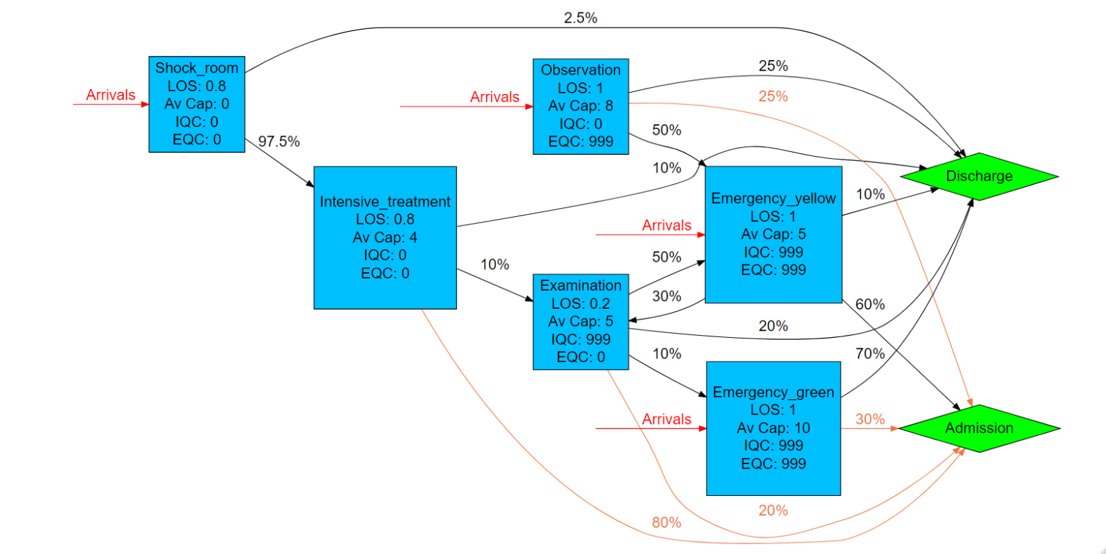

Figure

## Input templates

The Pathway Wizard also creates the following two parameter dataframes, which are used to generate the simulation. If the user has entered the data directly into the Pathway Wizard, it can be passed straight to the simulation model without the need for the user to interact directly with these files – but they can be downloaded and saved, then subsequently re-uploaded to PathSimR if the user wishes to run the simulation again without having to re-enter data into the wizard, or if they wish to make changes to specific parameters (e.g. for sensitivity analysis, or “what-if” comparison on the effect of different capacities in given service points).

***Network template***

This template, and extract of which is shown in figure 2, includes transition rates between individual service points and exits, as well as service time parameters and permitted queue lengths for each service point. Note the service points each appear multiple times in the column headers, and the table is truncated at the right.



Figure

***Calendar template***

This template, shown in figure 3, includes the arrival schedule (times and associated arrival rates – possibly zero) and the capacity for each service point with a defined capacity and service time.



Figure

# Outputs summary

Simulation results for the system described above show substantial under-utilisation at most service points (with the exception of “emergency green”). For example, the “shock room” has an available capacity which varies between 3 and six concurrent patients depending on time of day, but has an average occupancy of only 0.24 patients, and has an occupancy of 1.66 patients or fewer 99% of the time (99th occupancy percentile).

The numerical results are summarised in figure 4 below, and a plot of the results for all service points is shown in figure 5 (note that the “shock room” has capacity to treat 6 patients concurrently between 8am and 8pm, and 2 patients concurrently otherwise, while capacities for all other units are constant over time).

**Numerical occupancy summary**

|  |  |  |  |  |  |  |  |  |
| --- | --- | --- | --- | --- | --- | --- | --- | --- |
|  | **Occupancy percentile** | | | | | | **Average Occupancy** | **Maximum capacity** |
| **node** | **80th** | **85th** | **90th** | **95th** | **99th** | **100th** |  |  |
| **Shock_room** | 0.05 | 0.33 | 0.6 | 0.87 | 1.66 | 4 | 0.24 | 6 |
| **Intensive_treatment** | 0.37 | 0.58 | 0.78 | 0.99 | 1.9 | 4 | 0.34 | 4 |
| **Observation** | 0.83 | 0.98 | 1.38 | 1.83 | 2.81 | 7 | 0.66 | 8 |
| **Emergency_yellow** | 1.34 | 1.62 | 1.9 | 2.53 | 3.68 | 5 | 0.98 | 5 |
| **Emergency_green** | 4.99 | 5.52 | 6.09 | 7.04 | 9.04 | 10 | 3.85 | 10 |
| **Examination** | 0 | 0 | 0 | 0.52 | 0.95 | 4 | 0.10 | 5 |

Figure

**Graphical occupancy summary**

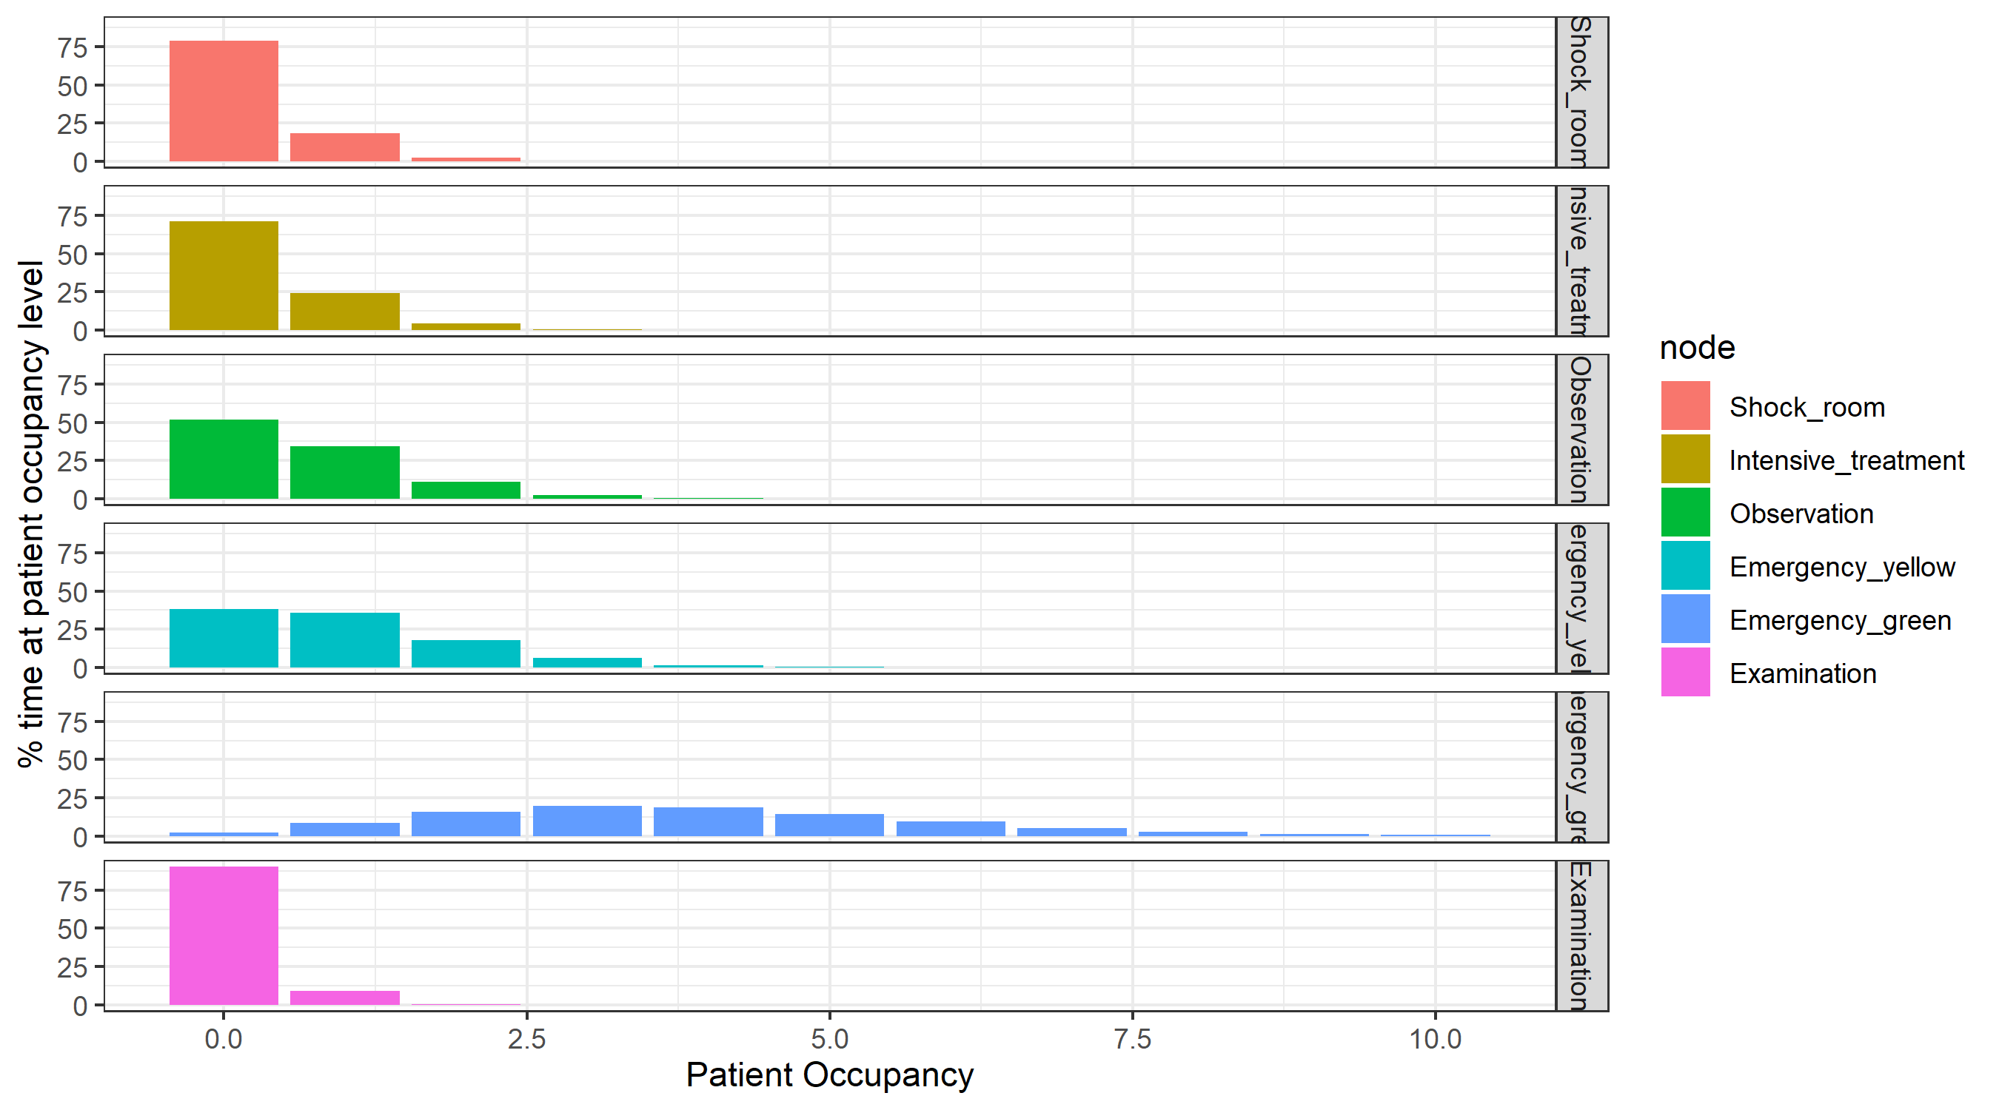

Figure

Capacity-driven delays resulting from this pathway setup are negligible (as might be expected given the levels of underutilisation), and the proportion of time delayed awaiting discharge is also small, and mainly concentrated in the “emergency green” service point (note that this directly reflects the specification of prescribed delays to discharge in the pathway description).

Queues are also negligible, with patients only ever queuing at the “emergency yellow” and “emergency green” service points, and queues there being uncommon and small (“emergency yellow” maximum queue size 3, mean queue size 0.003, and no queue at all 99% of the time; “emergency green” maximum queue size 8, mean queue size 0.009, and no queue at all 99% of the time).

PathSimR – Obstetrics Example

# Problem

## Project title & summary

**Obstetrics Hospital Pathway based on published study by Cochran & Bharti 2006** (Reference at end of document)

The paper authors were interested in a variety of insights particularly how beds could be reallocated to different areas of the pathway to reduce blocking of beds whilst maintaining bed unit utilization.

The following set of tables outlines how one of their ‘what if’ studies can be translated into PathSimR. All assumptions involved with this translation can be found in the Assumptions and Limitations section of this document.

## Key PathSimR Features

* Zero length internal queue system leading to potential capacity driven delays (blocking after service)
* Rejection at full external queues (patients will be lost if there is no space upon arrival from outside the system)
* Multiple external arrival points, each with a unique arrival rate
* Small cycles within the network

## Summary of services along patient pathway

|  |  |  |
| --- | --- | --- |
| Service Point | Service Point Type | Description |
| Triage | Bedded Unit | * Capacity: 10 Beds * Average LoS: 3.2 Hours * Modelled as a log-normal Distribution with logmean=0.97 and logsd =0.51 |
| Ante Partum Monitored (APM) | Bedded Unit | * Capacity: 16 Beds * Average LoS: 126.34 Hours * Modelled as a log-normal Distribution with logmean=4.831 and logsd =0.1257 |
| Ante Partum Not Monitored (APNM) | Bedded Unit | * Capacity: 14 Beds * Average LoS: 126.34 Hours * Modelled as a log-normal Distribution with logmean=4.831 and logsd =0.1257 |
| Labour & Delivery (LD) | Bedded Unit | * Capacity: 26 Beds * Average LoS: 8.01 Hours * Modelled as a log-normal Distribution with logmean=2.008 and logsd =0.3818 |
| Post Partum (PP) | Bedded Unit | * Capacity: 48 Beds * Average LoS: 46.71 Hours * Modelled as a Gamma Distribution with shape=4.831 and rate =0.0738 |
| Recovery PACU (PACU) | Bedded Unit | * Capacity: 6 Beds * Average LoS: 3.5 Hours * Modelled as a Uniform Distribution with min=3 and max=4 |
| Medical/ Surgical Women (MSW) | Bedded Unit | * Capacity: 30 Beds * Average LoS: 68.51 Hours * Modelled as a log-normal Distribution with logmean=4.219 and logsd =0.1252 |

## Summary of exits from patient pathway

|  |  |  |
| --- | --- | --- |
| Exit | Possible Discharge Delay | Description |
| Home | No Delay | Only exit in pathway |

## External arrival rates to the patient pathway and queue capacity

|  |  |  |
| --- | --- | --- |
| Service Point | Arrival Rate Estimation | Queue Capacity |
| Triage | 1.64 per hour | **External:** 9999  **Internal:** 0 |
| Ante Partum Monitored (APM) | 0.008 per hour | **External:** 9999  **Internal:** 0 |
| Ante Partum Not Monitored (APNM) | 0.006 per hour | **External:** 9999  **Internal:** 0 |
| Labour & Delivery (LD) | 0.333 per hour | **External:** 0  **Internal:** 0 |
| Post Partum (PP) | N/A | **External:** 0  **Internal:** 0 |
| Recovery PACU (PACU) | N/A | **External:** 0  **Internal:** 0 |
| Medical/ Surgical Women (MSW) | 0.135 per hour | **External:** 0  **Internal:** 0 |

## Features of the patient pathway

|  |  |  |
| --- | --- | --- |
| Service Point | Onward Service Points or Exits | Additional Information |
| Triage | APM: 1.62%  APNM: 1.38%  Labour & Delivery (LD): 38.5%  Home: 58.5% |  |
| Ante Partum Monitored (APM) | Labour & Delivery (LD):50%  Home: 50% |  |
| Ante Partum Not Monitored (APNM) | Labour & Delivery (LD):25%  Home: 75% |  |
| Labour & Delivery (LD) | APM: 7%  APNM: 3%  Post Partum (PP): 64.97%  Recovery PACU (PACU): 24.03%  Medical/ Surgical Women (MSW): 1% |  |
| Post Partum (PP) | Home: 100% |  |
| Recovery PACU (PACU) | Home: 100% |  |
| Medical/ Surgical Women (MSW) | Home: 100% |  |

## Assumptions and limitations

PathSimR implements the following assumptions into the model:

* Allows for blocking after service (capacity driven delays) whereby a patient cannot move onto the next unit until a space becomes available. They therefore remain in their current location, stopping a new patient taking their place. This is not readily implemented in the paper and therefore represents a deviation in approach.
* Zero length queues around the Labour and Delivery Unit to represent the inability of a patient to wait without being in a treatment point. Triage, APM and APNM have queues for arrivals from outside the system which represent locations where patients are allowed to wait.
* This model has removed the NICU (New-born Intensive Care Unit) as it represents a shift in patient class (mother to child) and should be modelled separately.
* In the original study, there were multiple classes of patient in the Triage Unit, each of which had a different service length. PathSimR does not allow for patient classes and therefore a new service distribution was created that captures the range of service lengths and the number of patients experiencing them (based on data from the paper).

This pathway includes loops back from the Labour and Delivery Unit to the Ante Partum Units. These loops are modelled in the simulation but have an impact on the reliability of the Patient based metrics in the outputs. It is therefore advised that the user only investigate the service point based metrics (Occupancy, Queue Length, # Experiencing Capacity Driven Delays etc.) when there is a loop in the system. Moreover, in high demand cycles, the model could seize up in deadlock if two patients try to simultaneously move between the same pair of service points (i.e. each is occupying the capacity the other is seeking to move to, and hence cannot relinquish the capacity they are using). This issue is only the case where there are service point cycles in the pathway.

Based on *Cochran, Jeffery & Bharti, Aseem. (2006). Stochastic bed balancing of an obstetrics hospital. Health care management science. 9. 31-45. 10.1007/s10729-006-6278-6.*

# Inputs

## Pathway Figure

Entering the pathway information above into the PathSimR Pathway Wizard, a set of model inputs and a pathway visualisation were automatically created. The pathway diagram (a static version of the tool output is presented in figure 1) serves as a sense check on whether the inputs have been entered correctly, and can inform discussion about what parameters or service point configurations might be varied in what-if analysis.

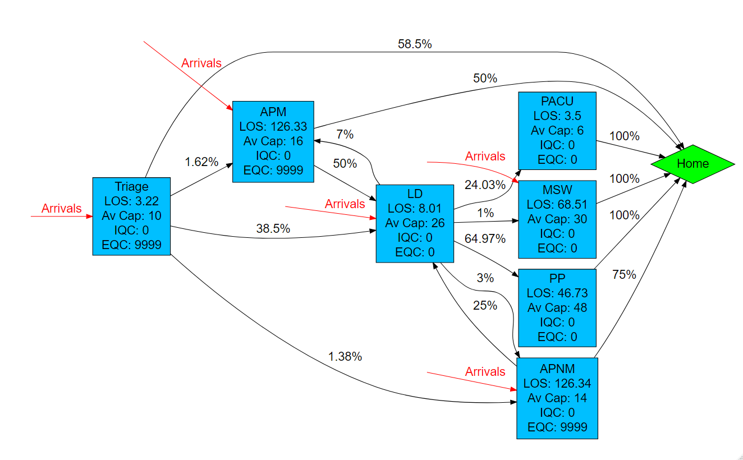

Figure 1

## Input templates

The Pathway Wizard also creates the following two parameter dataframes, which are used to generate the simulation. If the user has entered the data directly into the Pathway Wizard, it can be passed straight to the simulation model without the need for the user to interact directly with these files – but they can be downloaded and saved, then subsequently re-uploaded to PathSimR if the user wishes to run the simulation again without having to re-enter data into the wizard, or if they wish to make changes to specific parameters (e.g. for sensitivity analysis, or “what-if” comparison on the effect of different capacities in given service points).

***Network template***

This template, and extract of which is shown in figure 2, includes transition rates between individual service points and exits, as well as service time parameters and permitted queue lengths for each service point. Note the service points each appear multiple times in the column headers, and the table is truncated at the right.



Figure 2

***Calendar template***

This template, shown in figure 3, includes the arrival schedule (times and associated arrival rates – possibly zero) and the capacity for each service point with a defined capacity and service time.



Figure 3

# Outputs summary

Simulation results for the system described above show a bottleneck at “APM” (occupancy is greater than 15 – so the service point is effectively full and unable to receive new arrivals or transfers – more than 20% of the time, with an average occupancy of 13.24) and conversely substantial under-utilisation at “MSW” (occupancy less than 18.16 patients 99% of the time, mean occupancy 10.10, and maximum occupancy during simulation of 23 patients, against a maximum capacity of 30).

There is also evidence of more under-utilisation at both “LD” (occupancy less than 16.66 patients 99% of the time, average occupancy 8.8 patients, and maximum occupancy during simulation of 25 patients, against a maximum capacity of 26), and to a lesser extent at “PACU” (occupancy less than 3.43 patients 99% of the time and a mean occupancy of 0.91 patients, against a maximum capacity of 6).

The numerical results are summarised in figure 4 below, and a plot of the results for all service points is shown in figure 5.

**Numerical occupancy summary**

|  |  |  |  |  |  |  |  |  |
| --- | --- | --- | --- | --- | --- | --- | --- | --- |
|  | **Occupancy percentile** | | | | | | **Average occupancy** | **Maximum capacity** |
| **node** | **80th** | **85th** | **90th** | **95th** | **99th** | **100th** |  |  |
| **Triage** | 7.14 | 7.7 | 8.43 | 9.27 | 9.85 | 10 | 5.58 | 10 |
| **APM** | 15.41 | 15.56 | 15.7 | 15.85 | 15.97 | 16 | 13.24 | 16 |
| **APNM** | 9.6 | 10.23 | 11.07 | 12.14 | 13.51 | 14 | 7.56 | 14 |
| **LD** | 10.85 | 11.55 | 12.44 | 13.8 | 16.66 | 25 | 8.80 | 26 |
| **PP** | 34.86 | 35.99 | 37.38 | 39.63 | 43.38 | 48 | 30.73 | 48 |
| **PACU** | 1.18 | 1.48 | 1.78 | 2.28 | 3.43 | 6 | 0.91 | 6 |
| **MSW** | 12.33 | 12.95 | 13.78 | 15.03 | 18.16 | 23 | 10.10 | 30 |

Figure 4

**Graphical occupancy summary**

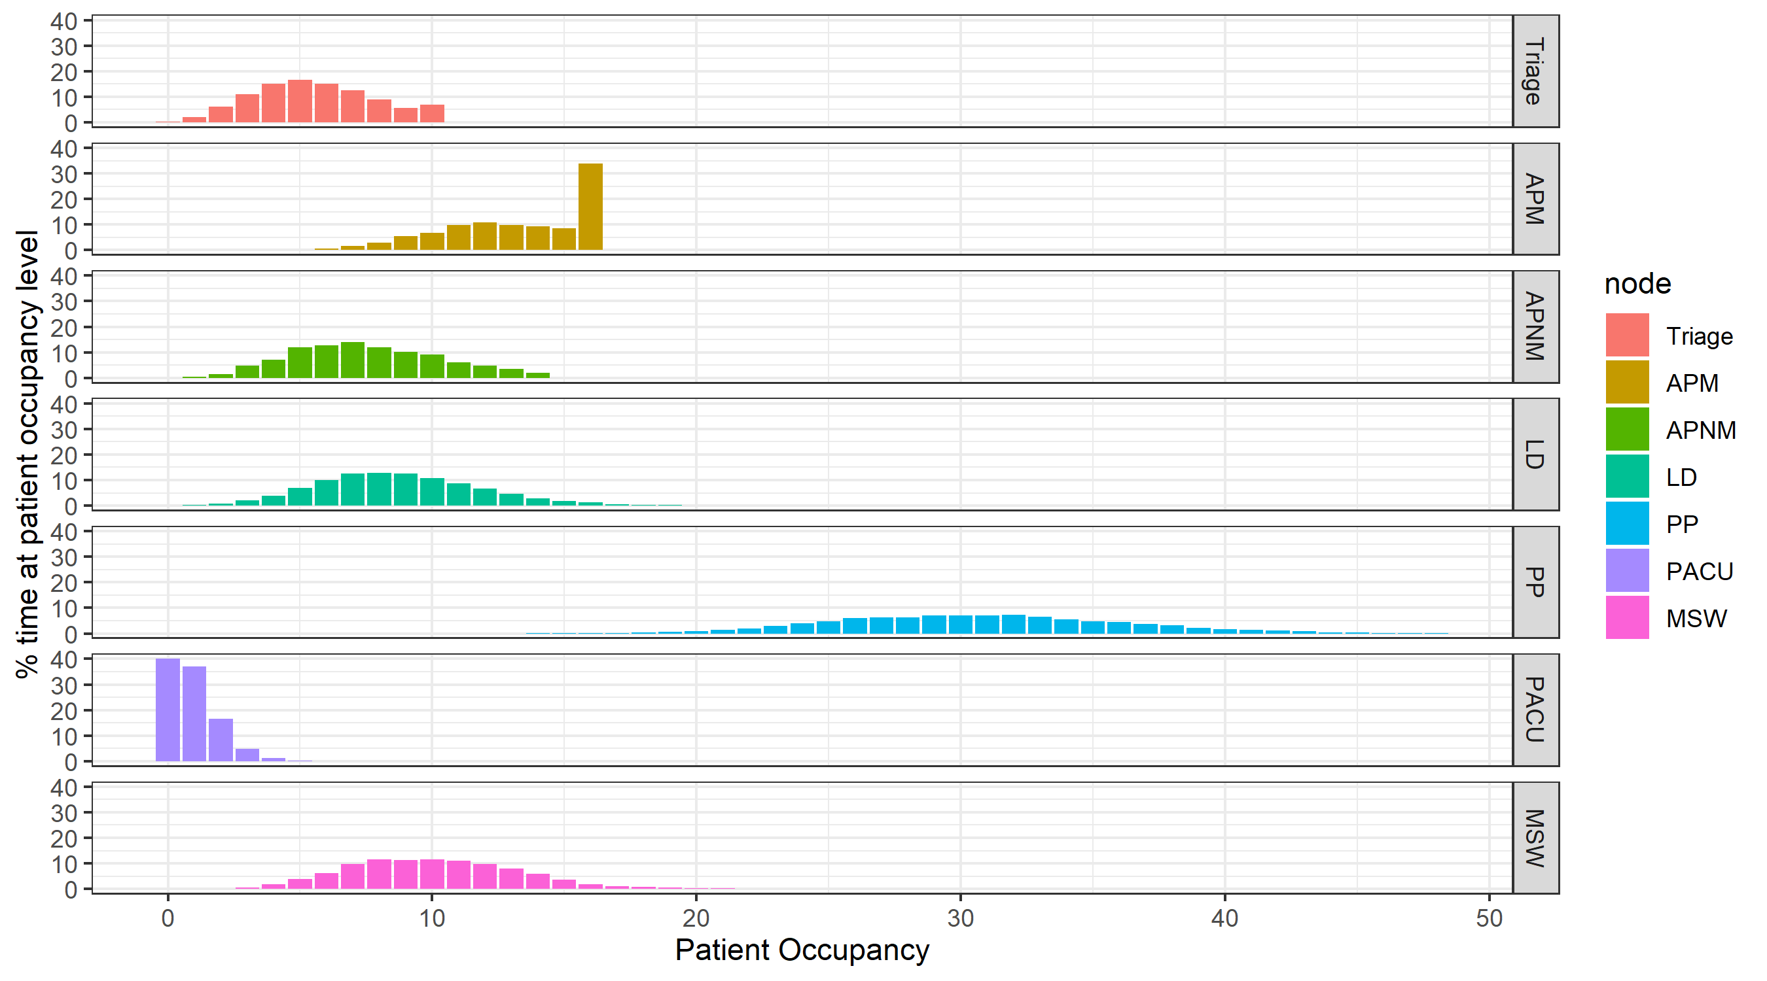

Figure 5

The bottlenecks described above give rise to capacity-driven delays (blocking after service) at “Triage” (average number of patients concurrently delayed 0.25, with more than 5% of the time there being more than 1.21 patients delayed), and at “LD” (average number of patients delayed 0.57, with 20% of the time there being on average more than 0.36 patients delayed, and 1% of the time more than 5.88). Both of service points are upstream from the bottleneck at “APM”, which is likely the main contributor to their delays.

There is a small amount of queueing at “Triage” (less than 2.52 patients 99% of the time, mean over simulation period 0.09) and “APM” (less than 0.93 patients 99% of the time, mean 0.06) and a negligible amount at “APNM”.

PathSimR – Stroke Reconfiguration Example

# Problem

## Project title & summary

**Capacity modelling to support stroke reconfiguration**

This example pathway is based on ongoing work by BNSSG CCG to investigate the reconfiguration of the acute stroke care pathway across the sub-region, including theoretical results published by the CCG’s Modelling and Analytics team.[2] The numbers used in this example are illustrative of the problem and do not represent actual values.

## Key questions & insights

* Number of beds required in both HASU and ASU wards so that the probability of a patient arriving and finding HASU full is <1%.

## Key PathSimR Features

* Includes both Capacity Driven Delays & Transition Departure Delays (to exits)
* Infinite queue for external arrivals to a unit. This could be changed to a zero queue length to investigate different dynamics in the system.
* Zero length internal queues to replicate continuous bedded care across multiple service points.

## Summary of services along patient pathway

|  |  |  |
| --- | --- | --- |
| Service Point | Service Point Type | Description |
| Hyper Acute Stroke Unit (HASU) | Continuous care bedded ward | * # of beds to be determined by analysis (initial estimate = 40) * Number of beds is fixed throughout the year * LOS: 3.3 days (exponential with rate = 0.3030) |
| Acute Stroke Unit (ASU) | Continuous care bedded ward | * # of beds to be determined by analysis (initial estimate = 35) * Number of beds is fixed throughout the year * LOS: 7.7 days (exponential with rate = 0.13) |
| Subacute 1  (SA1) | Continuous care bedded ward | * # of beds to be determined by analysis * (initial estimate = 20) * Number of beds is fixed throughout the year * LOS: 24 days (exponential with rate = 0.0417) |
| Subacute 2  (SA2) | Continuous care bedded ward | * # of beds to be determined by analysis * (initial estimate = 20) * Number of beds is fixed throughout the year * LOS: 24 days (exponential with rate = 0.0417) |

## Summary of exits from patient pathway

|  |  |  |
| --- | --- | --- |
| Exit | Possible Discharge Delay | Description |
| Home | 0.5 day delay | No care or rehab needs |
| Home & ESD (Early Supported Discharge) | 1.5 days delay |  |
| Stroke repat | 2 day delay |  |
| Simple (1&2) | 1.5 days | Represents a grouping of lower delay exits |
| Complex (1&2) | 2 days | Represents a grouping of higher delay exits |
| Mimics | N/A |  |
| Mortality | N/A |  |

## External arrival rates to the patient pathway and queue capacity

|  |  |  |
| --- | --- | --- |
| Service Point | Arrival Rate Estimation | Queue Capacity |
| Hyper Acute Stroke Unit (HASU) | 5.14/day (exponential distn) | **External:** 9999  **Internal:** 0 |
| Acute Stroke Unit (ASU) | N/A | **External:** 0  **Internal:** 0 |
| Subacute 1  (SA1) | N/A | **External:** 0  **Internal:** 0 |
| Subacute 2  (SA2) |  |  |

## Features of the patient pathway

***Please provide a brief overview of how the services are connected within the pathways and where patients can exit to. It may be helpful to provide an initial sketch of the network in parts or whole. An estimation of the percentage of patients that move between each service point would also be helpful. Also indicate any special rules that may apply within these service points or the queues connecting them.***

|  |  |  |
| --- | --- | --- |
| Service Point | Onward Service Points or Exits | Additional Information |
| Hyper Acute Stroke Unit (HASU) | ASU – 42%  Mimics – 25%  Home – 15%  Home & ESD – 7.5%  Stroke repat – 3%  Mortality – 7.5% |  |
| Acute Stroke Unit (ASU) | Subacute 1 – 35%  Subacute 2 – 22.5%  Stroke repat – 2%  Home – 9%  Home & ESD – 27%  Mortality – 4.5% |  |
| Subacute 1  (SA1) | Complex 1 – 71%  Simple 1 – 29% |  |
| Subacute 2  (SA2) | Complex 2 – 71%  Simple 2 – 29% |  |

## Assumptions and limitations

***Please provide a brief overview of any assumptions made in the description above and any limitations that the model may not be able to accurately simulate.***

* The model assumes an infinitely large queue can grow at the front of the HASU unit. This is in order to enforce a realistic arrival rate. If the queue was removed then an outcome of the model would be that patients may be lost from the system upon arrival. In reality, patients would wait (typically in A&E) for a limited amount of time before either being admitted or being outlied in a different department. The purpose letting the queue form in this model was to estimate the capacity required to constrain it to an acceptable size while also satisfying downstream performance measures.

# Inputs

## Pathway Figure

Entering the pathway information above into the PathSimR Pathway Wizard, a set of model inputs and a pathway visualisation were automatically created. The pathway diagram (a static version of the tool output is presented in figure 1) serves as a sense check on whether the inputs have been entered correctly, and can inform discussion about what parameters or service point configurations might be varied in what-if analysis.

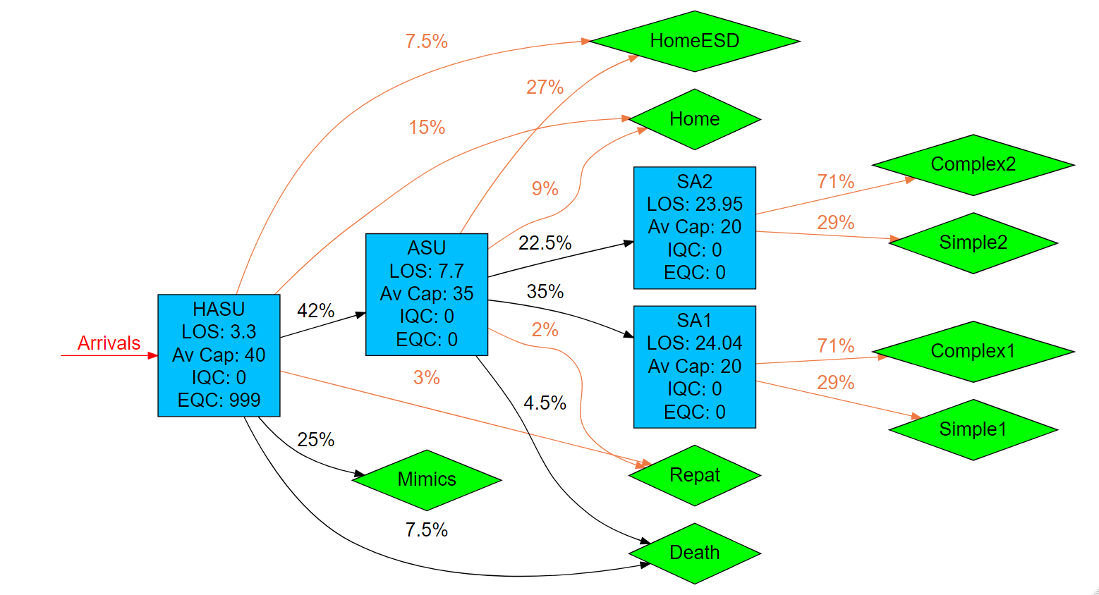

Figure 1

## Input templates

The Pathway Wizard also creates the following two parameter dataframes, which are used to generate the simulation. If the user has entered the data directly into the Pathway Wizard, it can be passed straight to the simulation model without the need for the user to interact directly with these files – but they can be downloaded and saved, then subsequently re-uploaded to PathSimR if the user wishes to run the simulation again without having to re-enter data into the wizard, or if they wish to make changes to specific parameters (e.g. for sensitivity analysis, or “what-if” comparison on the effect of different capacities in given service points).

***Network template***

This template, and extract of which is shown in figure 2, includes transition rates between individual service points and exits, as well as service time parameters and permitted queue lengths for each service point. Note the service points each appear multiple times in the column headers, and the table is truncated at the right.



Figure 2

***Calendar template***

This template, shown in figure 3, includes the arrival schedule (times and associated arrival rates – possibly zero) and the capacity for each service point with a defined capacity and service time.



Figure 3

# Outputs summary

Simulation results for the system described above show that the capacity is insufficient to meet the stated objective of patients arriving to find no “HASU” beds available less than 1% of the time. This appears to be the results of a combination of capacity constraint at “HASU”, and also downstream.

In particular, “HASU” is effectively full (fewer than one bed free) more than 10% of the time (99% occupancy 39.93 against a full capacity of 40), despite average occupancy being only 22.35 patients. There is also a substantial queue at “HASU” (rising to more than 17 patients 10% of the time, with an average queue size of 8.88). Capacity is also severely constrained at both “ASU” and “SA1” which are both effectively full 20% of the time (80% percentile occupancy 34.31 vs full capacity of 35 at “ASU”, and 19.74 vs full capacity of 20 at “SA1”). Note that mean occupancy at “ASU” is 25.79, substantially below its full capacity, while “SA1” is more uniformly full, with an average occupancy of 19.11.

The numerical results are summarised in figure 4 below, and a plot of the results for all service points shown in figure 5.

**Numerical occupancy summary**

|  |  |  |  |  |  |  |  |  |
| --- | --- | --- | --- | --- | --- | --- | --- | --- |
|  | **Occupancy percentile** | | | | | | **Average occupancy** | **Maximum capacity** |
| **node** | **80th** | **85th** | **90th** | **95th** | **99th** | **100th** |  |  |
| **HASU** | 27.85 | 35.7 | 39.27 | 39.64 | 39.93 | 40 | 22.35 | 40 |
| **ASU** | 34.31 | 34.48 | 34.66 | 34.83 | 34.97 | 35 | 25.79 | 35 |
| **SA1** | 19.74 | 19.81 | 19.87 | 19.94 | 19.99 | 20 | 19.11 | 20 |
| **SA2** | 15.24 | 16.06 | 17.1 | 18.58 | 19.75 | 20 | 12.64 | 20 |

Figure 4

**Graphical occupancy summary**

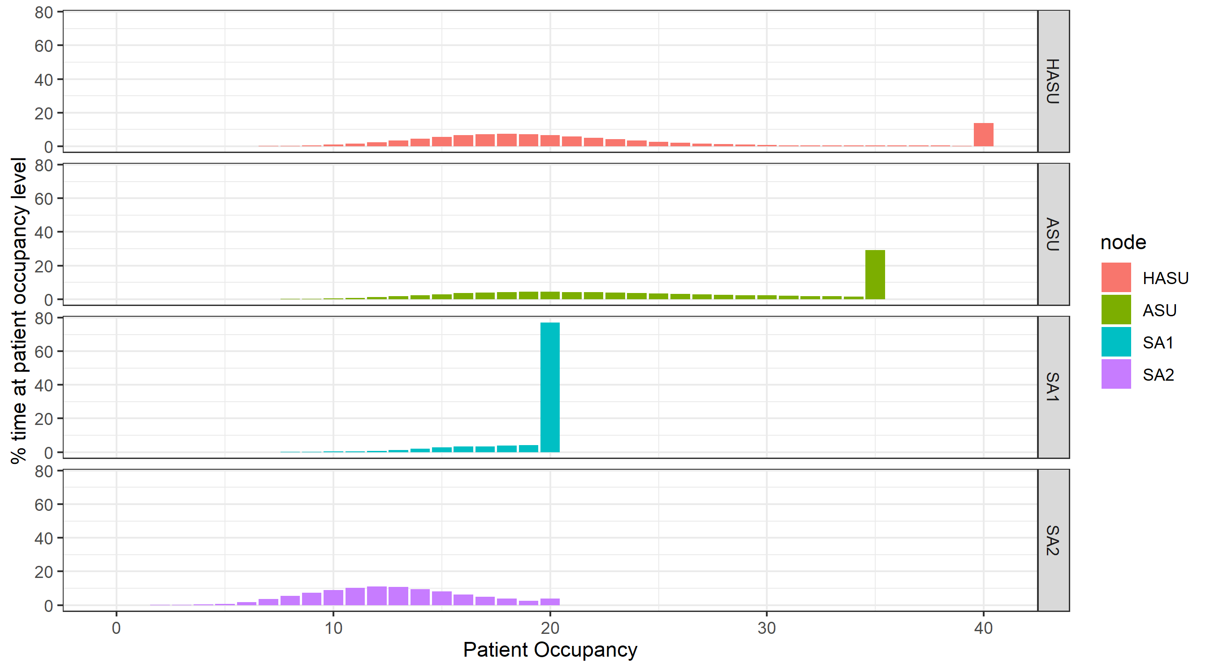

Figure 5

The downstream bottlenecks at “SA1” (and “ASU”) lead to substantial levels of capacity-driven delays at both “HASU” (mean 4.24 patients concurrently delayed, 5% of the time more than 23) and “ASU” (mean 8.12 patients concurrently delayed, 5% of the time more than 20).

PathSimR – Urology Mixed Pathway Example

# Problem

## Project title & summary

**Understanding bottlenecks in a hypothetical Urology Pathway**

The pathway modelled in this project represents a mix of outpatient clinics and an inpatient bedded ward, framed in a urology setting. This basic framework was created after discussions with urology service commissioners and showcases key features of real pathways.

Each of the clinics and the inpatient elective ward have queues (a single queue each) before them. In this example, these queues are not physical waiting spaces but instead represent all people waiting for the next available clinic space. There is therefore no upper limit to the queue length as people can wait in their homes until the next space is available. This pathway network’s primary goal is to provide insight into bottlenecks in the system, to see where demand outstrips capacity.

## Key PathSimR Features

* Infinitely large internal queue system
* Calendar driven capacity (including clinics that close)
* Mixed pathway
  + Outpatient clinics
  + Inpatient bedded ward
* Mix of Service Distributions

## Key questions & insights

* Which services have growing queues?
* Is it a better strategy to increase the length of time that the clinics are open or increase the number of staff at each service point?

## Summary of services along patient pathway

|  |  |  |
| --- | --- | --- |
| Service Point | Service Point Type | Description |
| GP Referral (GP_Ref) | Fixed Hours service | * Service operates between 9am & 6pm everyday * 10 GPs available * Appointments take between 12 & 24 minutes (modelled as uniform distribution with min = 0.2 & max = 0.4) |
| Hospital Clinic (H_C) | Fixed Hours service | * Service operates between 9am & 3pm everyday * 6 staff available * Appointments take between 15 & 45 minutes (modelled as uniform distribution with min = 0.25 & max = 0.75) |
| Hospital Diagnostics (H_D) | Fixed Hours service | * Service operates between 12pm & 6pm everyday * 7 staff available * Appointments take between 15 & 45 minutes (modelled as uniform distribution with min = 0.25 & max = 0.75) |
| Hospital Ward (H_W) | Continuous Bedded Unit | * 75 beds available * Treatment takes on average 4 days(modelled as exponential distribution with rate = 0.0104) |
| Bladder & Bowel Clinic (B_B) | Fixed Hours service | * Service operates between 10am & 12pm everyday * 8 staff available * Appointments take between 15 & 30 minutes (modelled as uniform distribution with min = 0.25 & max = 0.5) |
| Blended Clinical Triage (BCT) | Fixed Hours service | * Service operates between 9am & 3pm everyday * 9 staff available * Appointments take between 15 & 30 minutes (modelled as uniform distribution with min = 0.25 & max = 0.5) |
| Community Clinic (CC) | Fixed Hours service | * Service operates between 9am & 12pm everyday * 10 staff available * Appointments take between 15 & 45 minutes (modelled as uniform distribution with min = 0.25 & max = 0.75) |
| Community Follow-Up (CF) | Fixed Hours service | * Service operates between 12pm & 3pm everyday * 5 staff available * Appointments take between 15 & 45 minutes (modelled as uniform distribution with min = 0.25 & max = 0.75) |
| Specialist Clinic (SC) | Fixed Hours service | * Service operates between 9am & 12pm everyday * 10 staff available * Appointments take between 15 & 45 minutes (modelled as uniform distribution with min = 0.25 & max = 0.75) |
| Specialist Follow-Up (SF) | Fixed Hours service | * Service operates between 12pm & 3pm everyday * 5 staff available * Appointments take between 15 & 45 minutes (modelled as uniform distribution with min = 0.25 & max = 0.75) |

## Summary of exits from patient pathway

|  |  |  |
| --- | --- | --- |
| Exit | Possible Discharge Delay | Description |
| Home | No Delay |  |

## External arrival rates to the patient pathway and queue capacity

|  |  |  |
| --- | --- | --- |
| Service Point | Arrival Rate Estimation | Queue Capacity |
| GP Referral (GP_Ref) | 6 per hour | **External:** 9999  **Internal:** 0 |
| Hospital Clinic (H_C) | 0 per hour | **External:** 0  **Internal:** 9999 |
| Hospital Diagnostics (H_D) | 0 per hour | **External:** 0  **Internal:** 9999 |
| Hospital Ward (H_W) | 0 per hour | **External:** 0  **Internal:** 9999 |
| Bladder & Bowel Clinic (B_B) | 0 per hour | **External:** 0  **Internal:** 9999 |
| Blended Clinical Triage (BCT) | 0 per hour | **External:** 0  **Internal:** 9999 |
| Community Clinic (CC) | 0 per hour | **External:** 0  **Internal:** 9999 |
| Community Follow-Up (CF) | 0 per hour | **External:** 0  **Internal:** 9999 |
| Specialist Clinic (SC) | 0 per hour | **External:** 0  **Internal:** 9999 |
| Specialist Follow-Up (SF) | 0 per hour | **External:** 0  **Internal:** 9999 |

## Features of the patient pathway

|  |  |  |
| --- | --- | --- |
| Service Point | Onward Service Points or Exits | Additional Information |
| GP Referral (GP_Ref) | Hospital Clinic (H_C): 50%  Bladder & Bowel Clinic (B_B): 15%  Blended Clinical Triage (BCT): 35% |  |
| Hospital Clinic (H_C) | Hospital Diagnostics (H_D): 90%  Home: 10% |  |
| Hospital Diagnostics (H_D) | Hospital Ward (H_W): 20%  Home: 80% |  |
| Hospital Ward (H_W) | Community Follow-Up (CF): 50%  Specialist Follow-Up (SF): 50% |  |
| Bladder & Bowel Clinic (B_B) | Blended Clinical Triage (BCT): 100% |  |
| Blended Clinical Triage (BCT) | Community Clinic (CC): 40%  Specialist Clinic (SC): 40%  Home: 20% |  |
| Community Clinic (CC) | Hospital Diagnostics (H_D): 10%  Community Follow-Up (CF): 10%  Home: 80% |  |
| Community Follow-Up (CF) | Home: 100% |  |
| Specialist Clinic (SC) | Specialist Follow-Up (SF): 10%  Home: 90% |  |
| Specialist Follow-Up (SF) | Home: 100% |  |

## Assumptions and limitations

In order to simplify the pathway, Uniform distributions were used to model the service times in the clinics. This means that there is an equal probability that the appointment will take any amount of time between the minimum and maximum values. This approach was taken instead of setting an explicit length (i.e. every appointment takes exactly 20 minutes) for each appointment in order to include some variability in the system.

# Inputs

## Pathway Figure

Entering the pathway information above into the PathSimR Pathway Wizard, a set of model inputs and a pathway visualisation were automatically created. The pathway diagram (a static version of the tool output is presented in figure 1) serves as a sense check on whether the inputs have been entered correctly, and can inform discussion about what parameters or service point configurations might be varied in what-if analysis.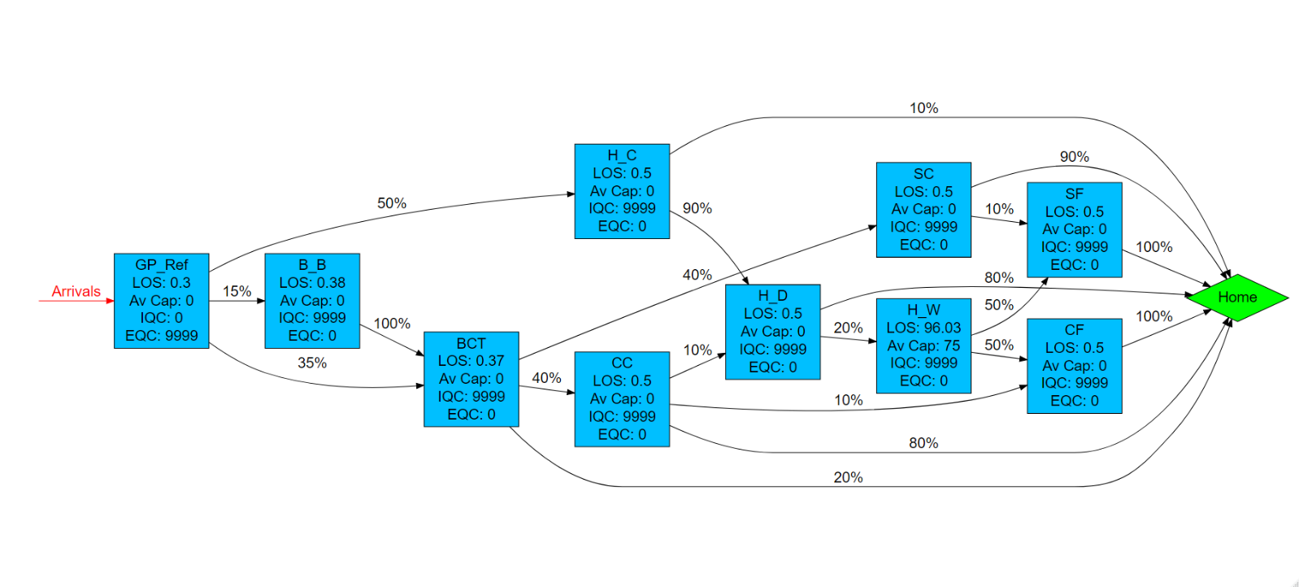

Figure 1

## Input templates

The Pathway Wizard also creates the following two parameter dataframes, which are used to generate the simulation. If the user has entered the data directly into the Pathway Wizard, it can be passed straight to the simulation model without the need for the user to interact directly with these files – but they can be downloaded and saved, then subsequently re-uploaded to PathSimR if the user wishes to run the simulation again without having to re-enter data into the wizard, or if they wish to make changes to specific parameters (e.g. for sensitivity analysis, or “what-if” comparison on the effect of different capacities in given service points).

***Network template***

This template, and extract of which is shown in figure 2, includes transition rates between individual service points and exits, as well as service time parameters and permitted queue lengths for each service point. Note the service points each appear multiple times in the column headers, and the table is truncated at the right.



Figure 2

***Calendar template***

This template, shown in figure 3, includes the arrival schedule (times and associated arrival rates – possibly zero) and the capacity for each service point with a defined capacity and service time. (Note that the table is truncated at the bottom).



Figure 3

# Outputs summary

Caution is necessary when interpreting the occupancy measures for service points which are closed for substantial portions of the simulation time (e.g. clinics closed overnight), since average measures of occupancy will deflate the occupancy levels when they are in active use.

From the plot of percent of simulation time at given occupancy level given in figure 4 below, it is evident that there are capacity constraints at “GP_Ref”, “H_C”, “H_D” and “BCT”, as evidenced by the spikes in occupancy frequency at the extreme end of their capacity (the bars on the right hand side), as well as on the left at zero occupancy (when they are closed).

**Graphical summary of occupancy**

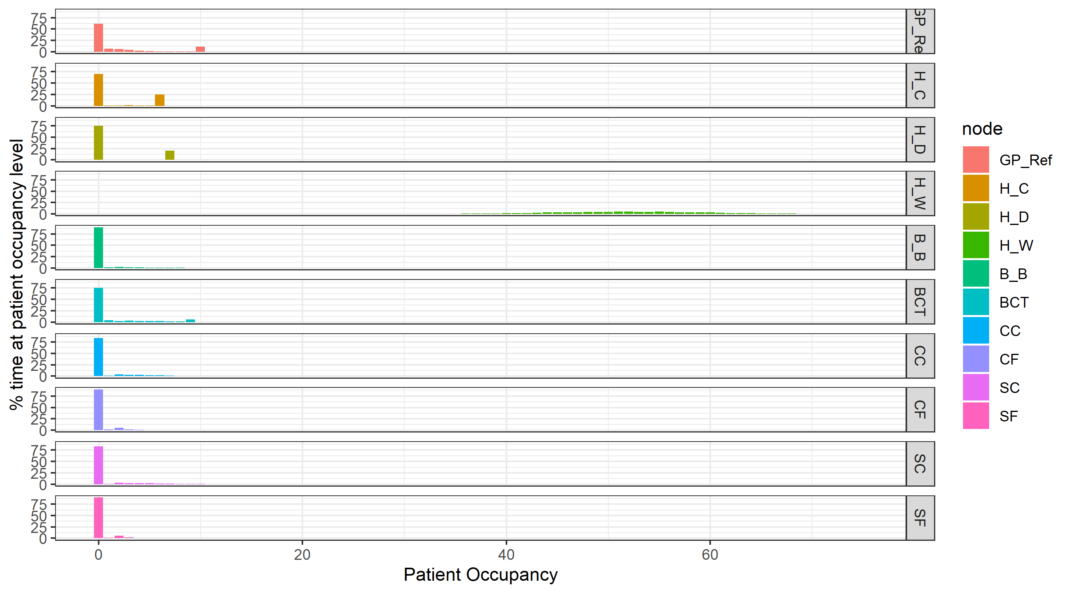

Figure 4

The main output measure of interest in this use case is queue size. Figure 5 below shows that substantial queues should be expected at “GP_Ref” (mean 35.44 patients waiting, and 5% of the time more than 85 patients waiting) and “HC” (mean 24.52 patients waiting, and 5% of the time more than 69 patients waiting), with smaller queues for other service points.

**Graphical summary of queue sizes**

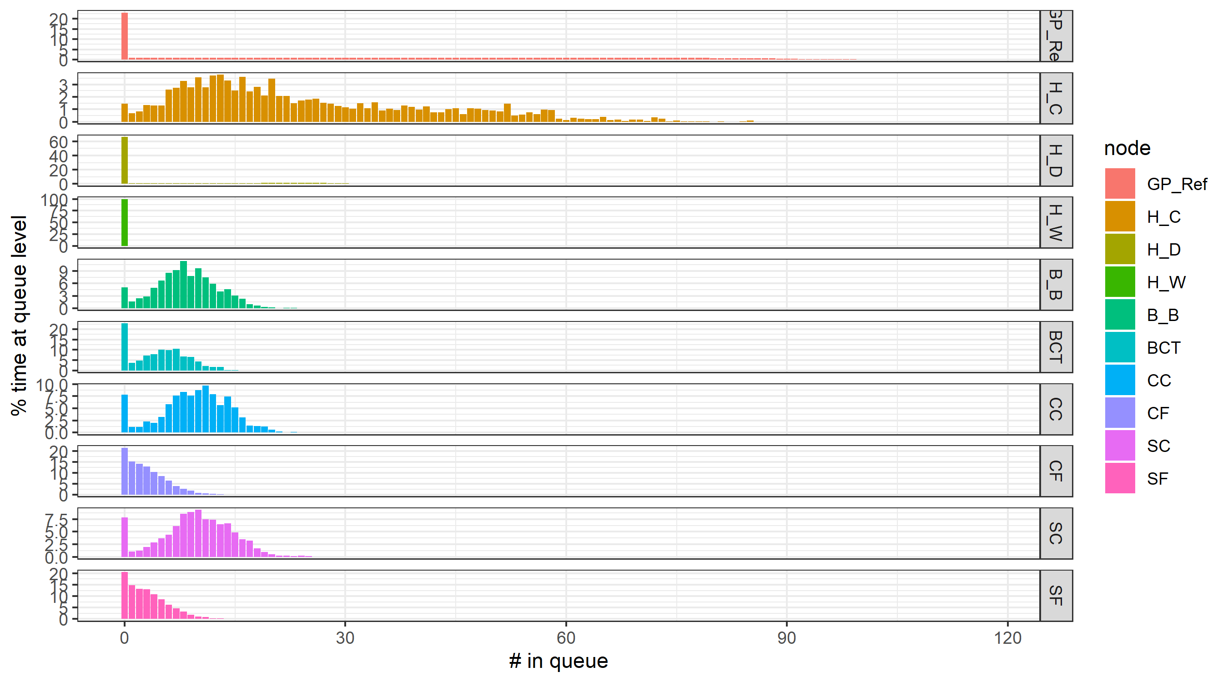

Figure 5

Further details of queue size are shown in figure 6 below

**Numerical summary of queue sizes**

|  |  |  |  |  |  |  |  |
| --- | --- | --- | --- | --- | --- | --- | --- |
|  | **Queue percentiles** | | | | | | **Mean queue** |
| **node** | **80th** | **85th** | **90th** | **95th** | **99th** | **100th** |  |
| **GP_Ref** | 66.95 | 72.71 | 78.63 | 85.83 | 96.39 | 118 | 35.45 |
| **H_C** | 39.57 | 44.73 | 50.11 | 56.37 | 69.93 | 88 | 24.52 |
| **H_D** | 16.19 | 20.1 | 23.32 | 26.5 | 30.63 | 39 | 5.99 |
| **H_W** | 0 | 0 | 0 | 0 | 0 | 6 | 0.00 |
| **B_B** | 11.38 | 12.33 | 13.5 | 14.88 | 17.52 | 23 | 8.38 |
| **BCT** | 7.54 | 8.29 | 9.08 | 10.46 | 12.65 | 18 | 4.76 |
| **CC** | 13.11 | 13.78 | 14.64 | 16.02 | 18.99 | 23 | 9.47 |
| **CF** | 4.65 | 5.32 | 6.16 | 7.62 | 10.46 | 18 | 2.95 |
| **SC** | 13.37 | 14.16 | 15.27 | 16.76 | 20.1 | 25 | 9.68 |
| **SF** | 4.86 | 5.6 | 6.53 | 7.85 | 10.68 | 18 | 3.10 |

1. Cimellaro, Malavisis and Mahin, Using Discrete Event Simulation Models to Evaluate Resilience of an Emergency Department, Journal of Earthquake Engineering, 2016, pp.1-24, doi:10.1080/13632469.2016.1172373
2. Richard M. Wood & Ben J. Murch (2019) Modelling capacity along a patient pathway with delays to transfer and discharge, Journal of the Operational Research Society, DOI: [10.1080/01605682.2019.1609885](https://doi.org/10.1080/01605682.2019.1609885)